**ESRGAN Documentation**

## **Overview**

ESRGAN is an advanced image super-resolution method that leverages deep learning and generative adversarial networks (GANs) to generate high-resolution images from low-resolution inputs. It employs a generator network to transform low-resolution images into high-resolution counterparts, while a discriminator network provides feedback for training and enhancing the visual quality of the generated images.

Project Description

ESRGAN (Enhanced Super-Resolution Generative Adversarial Network) is a deep learning-based image super-resolution method. It aims to generate high-resolution images from low-resolution inputs, enhancing their visual quality and level of detail. ESRGAN utilizes a generative adversarial network (GAN) framework, which consists of a generator network and a discriminator network.

The generator network in ESRGAN is responsible for transforming the low-resolution input images into high-resolution counterparts. It leverages deep convolutional neural networks (CNNs) to learn the mapping between the low-resolution and high-resolution image spaces. By learning from a large dataset of paired low-resolution and high-resolution images, the generator network can infer the missing high-frequency details and textures in the low-resolution inputs.

The discriminator network in ESRGAN plays a crucial role in training the generator network. It acts as a binary classifier, distinguishing between the generated high-resolution images and real high-resolution images from the training dataset. The generator aims to generate high-resolution images that are indistinguishable from real ones, while the discriminator aims to correctly classify the real and generated images.

ESRGAN incorporates an additional component known as the perceptual loss, which helps improve the visual quality of the generated images. The perceptual loss measures the perceptual similarity between the generated images and the corresponding ground truth high-resolution images using pre-trained deep CNNs, such as VGG networks. By optimizing both the adversarial loss from the discriminator and the perceptual loss, ESRGAN encourages the generator to produce visually pleasing and realistic high-resolution images.

ESRGAN has been widely used in various applications, including image upscaling, super-resolution in computer vision, and enhancing the visual quality of low-resolution images. It has demonstrated superior performance compared to traditional interpolation-based methods, producing images with sharper edges, finer details, and more realistic textures.

Overall, ESRGAN combines the power of deep learning, GANs, and perceptual loss to achieve impressive results in the field of image super-resolution, enabling the generation of high-quality, high-resolution images from low-resolution inputs.

TECHNOLGIES USED :

The ESRGAN project utilizes several key technologies to implement its image super-resolution method. Here are some of the core technologies used:

1. Deep Learning: ESRGAN is built upon deep learning techniques, specifically deep convolutional neural networks (CNNs). CNNs are used to model the mapping between low-resolution and high-resolution images, enabling the network to learn the intricate patterns and features necessary for image super-resolution.

2. Generative Adversarial Networks (GANs): ESRGAN leverages the GAN framework, which consists of a generator network and a discriminator network. The generator generates high-resolution images from low-resolution inputs, while the discriminator distinguishes between real high-resolution images and generated ones. The interplay between the generator and discriminator networks helps improve the quality and realism of the generated images.

3. Perceptual Loss: ESRGAN incorporates perceptual loss, which measures the perceptual similarity between the generated and ground truth high-resolution images. This loss function is computed using pre-trained deep CNNs, such as VGG networks. By optimizing the perceptual loss alongside the adversarial loss, ESRGAN encourages the generation of visually pleasing and realistic high-resolution images.

4. Convolutional Neural Networks (CNNs): CNNs are a fundamental component of ESRGAN, used in both the generator and discriminator networks. These networks consist of multiple layers of convolutional operations, enabling them to learn hierarchical representations of image features and capture the dependencies between pixels.

5. Python and Deep Learning Libraries: ESRGAN is typically implemented using Python programming language and popular deep learning libraries such as TensorFlow, PyTorch, or Keras. These libraries provide the necessary tools for building, training, and evaluating deep neural networks efficiently.

6. Dataset: ESRGAN requires a dataset of paired low-resolution and high-resolution images for training. This dataset serves as the ground truth for training the network and helps it learn the mapping between the two image spaces. Common datasets used in image super-resolution include DIV2K, BSDS500, and various publicly available datasets.

7. GPU Acceleration: Training and inference in ESRGAN can be computationally intensive. Therefore, GPU acceleration is often utilized to speed up the training process and enable faster generation of high-resolution images. GPUs provide parallel processing capabilities, which are well-suited for the matrix computations involved in deep learning algorithms.

These are some of the main technologies employed in the ESRGAN project. By combining deep learning, GANs, perceptual loss, and other supporting technologies, ESRGAN achieves state-of-the-art image super-resolution results.

## **Key Features**

* Super-resolution: ESRGAN can upscale low-resolution images to higher resolutions, enhancing their visual quality and level of detail.
* Generative Adversarial Network: The GAN framework in ESRGAN incorporates a generator network that generates high-resolution images and a discriminator network that distinguishes between real and generated images.
* Perceptual Loss: ESRGAN employs a perceptual loss function, which measures the perceptual similarity between generated and ground truth high-resolution images using pre-trained deep CNNs. This loss encourages the generation of visually pleasing and realistic results.
* Deep Convolutional Neural Networks: ESRGAN utilizes deep CNNs, such as VGG networks, to capture complex image features and learn the mapping between low-resolution and high-resolution image spaces.
* Python Implementation: ESRGAN is typically implemented using Python programming language and deep learning libraries such as TensorFlow, PyTorch, or Keras.

Network Architecture

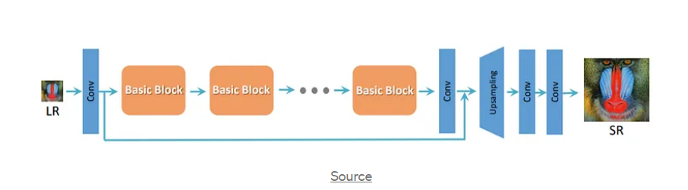

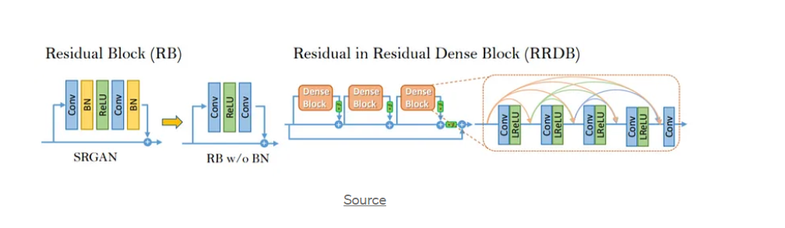

Snapshot :

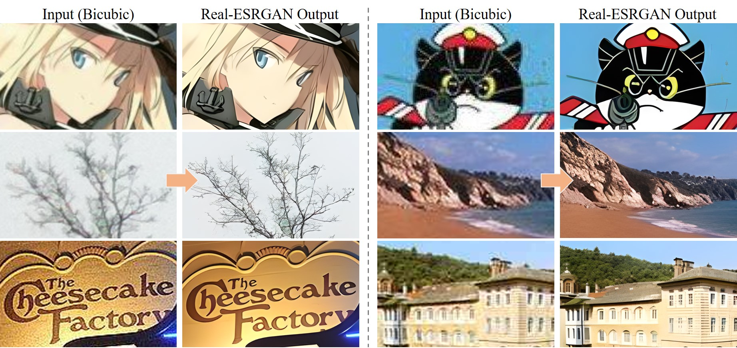

## **Examples and Results**

Include examples of input low-resolution images and their corresponding high-resolution outputs obtained using ESRGAN. Showcase the improved visual quality, enhanced level of detail, and realistic textures achieved by the model.

## **Conclusion**

ESRGAN is a powerful image super-resolution method that utilizes deep learning, GANs, and perceptual loss to generate high-quality, high-resolution images from low-resolution inputs. By following the installation and usage instructions, you can apply ESRGAN to various applications requiring image upscaling and enhancement.

Please note that this is a sample documentation for ESRGAN and should be customized and expanded according to the specific implementation and requirements of your project.

Important Links:

[Github](https://github.com/MadJokkerr/ESRGAN) , [Presentation](https://1drv.ms/p/s!AtD1BT0UTejLgzLHn_wChldklAwH?e=CtLLMc) , [Research Paper](https://arxiv.org/pdf/2107.10833v2.pdf)

Reference :

[Real-ESRGAN,](https://github.com/xinntao/Real-ESRGAN) [ESRGAN,](https://github.com/xinntao/ESRGAN) [Cornell University Reference,](https://arxiv.org/abs/1809.00219) [Published Paper 2018](https://openaccess.thecvf.com/content_ECCVW_2018/papers/11133/Wang_ESRGAN_Enhanced_Super-Resolution_Generative_Adversarial_Networks_ECCVW_2018_paper.pdf)